Student Name: Vasukumar Patel
Student Number: 041153940
Lab – 4 – R Language

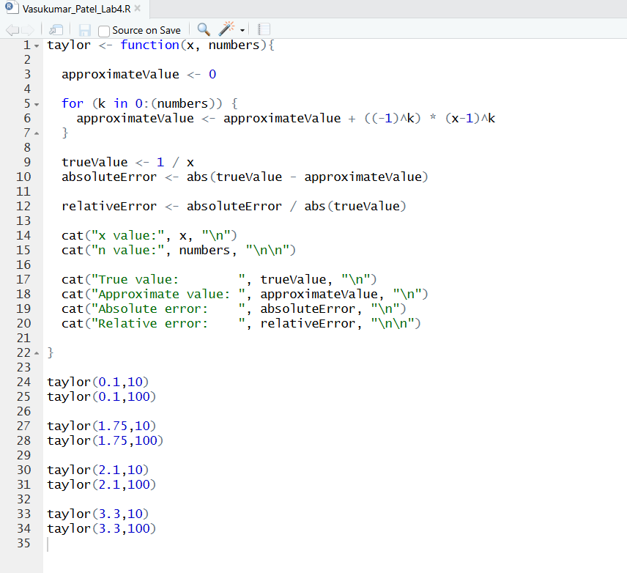

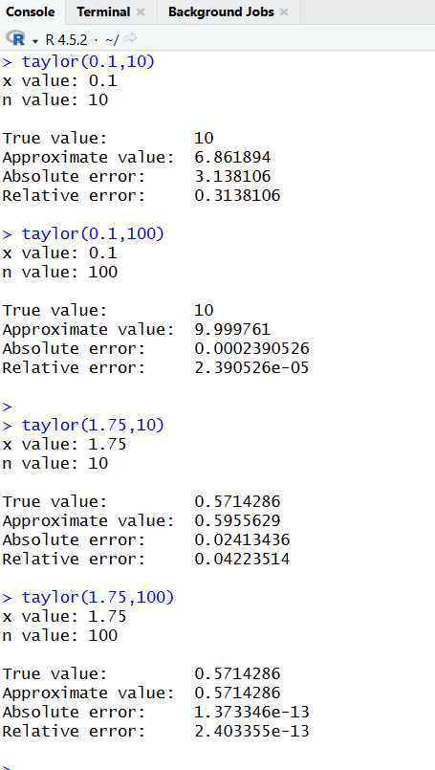

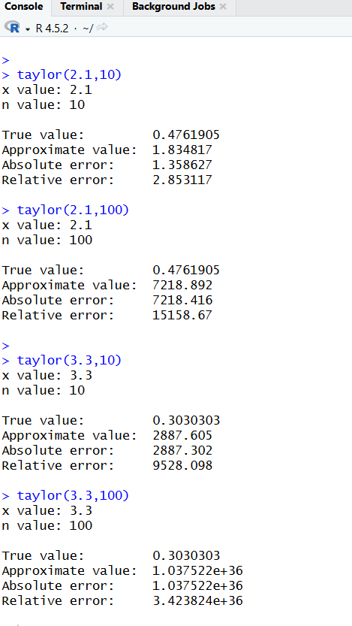

- What is happening to the accuracy of the approximation as n increases? Explain with examples your reasoning.
- As n increases, the accuracy depends on the value of x.
- When 0 < x < 2, the approximation becomes more accurate.
This is because the terms get smaller and the error decreases.
Example: for x = 0.1 and x = 1.75, the result is much better when n = 100 than n = 10.
- When x > 2, the approximation becomes less accurate.
This is because the terms get bigger and the error increases.
Example: for x = 2.1 and x = 3.3, the result becomes very wrong when n increases.

- What is happening to the accuracy of the approximation as x gets further away from the value of a (which is 1 for this lab)? Explain your reasoning with examples.
- As x gets further away from a = 1, the approximation becomes less accurate.
- Examples:
- x = 1.75
→ The approximation is very accurate, especially when n is large.
- x = 0.1
→ The approximation is less accurate at first, and needs a larger n to improve.
- x = 2.1 and x = 3.3
→ The approximation becomes very bad, even with large n.

- Which would be considered better for increasing the accuracy of the approximation? A larger value for n? Or values of x closer to a? Explain your decision.
- Values of x closer are better for increasing accuracy.
- Even if you make n larger, the approximation only improves when x is close to 1. If x is far from 1, increasing n may not help and can even make the result worse.

- Explain what is happening at x = 3.3 for n = 100.
- At x = 3.3 and n = 100, the approximation becomes very large and completely inaccurate because the values being added in the series keep getting bigger instead of smaller. This happens because x is far from 1, so the method no longer works properly. Instead of getting closer to the true value (which is about 0.303), the result keeps moving further away as n increases. This means the series is not converging and the approximation becomes worse when n is large.

- Explain why the sign is changing for the approximate value at x = 3.3 for n = 99.
- At x = 3.3, the sign changes because the formula includes (-1)^k, which makes each term alternate between positive and negative. So one term is added, the next is subtracted, and this pattern continues. When n = 99, the last term has an odd power, so it becomes negative, which can make the final approximate value negative. Since the terms are very large at this x value, the last term has a strong effect on the result, causing the overall sign to flip.

